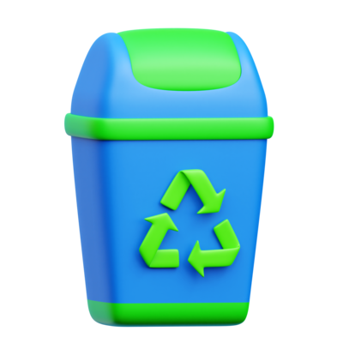REDUCE , REUSE , RECYCLE

IT IS VERY IMPORTANT TO

Reduce, Reuse, Recycle

TO SAVE THE ENVIORMENT AND SAVE YOUR LIVES

It is good for the environment to reuse things and recycle some so they can be turned into valuable things if you don’t need them anymore.

SO, SAVE YOUR LIFE BY SAVING THE ENVIRONMENT IN THESE WAYS

It is good for the environment to use less plastic.

